Watershed and oceanic controls on spatial and temporal patterns of sediment deposition in a fringing coral reef embayment: Faga'alu Bay, American Samoa

by

Messina, A.M.1*, Biggs, T.W.1, Storlazzi, C.D.2

1 San Diego State University, Department of Geography, San Diego, CA 92182, amessina@rohan.sdsu.edu, +1-619-594-5437, tbiggs@mail.sdsu.edu, +1-619-594-0902

2 US Geological Survey, Pacific Coastal and Marine Science Center, Santa Cruz, CA 95060, cstorlazzi@usgs.gov, +1-831-460-7521, ocheriton@usgs.gov, +1-831-460-7579

Abstract

Sediment accumulation (“sediment accumulation”) on SedPods and in Tubes was monitored quasi-monthly over a one-year period and related to measured and modeled suspended sediment yield from the adjacent watershed (SSY), mean monthly significant wave height (Waves), and circulation patterns in a small (0.4 km2) coral reef fringed embayment. Sediment traps were deployed at 9 sites in the bay to sample gradients in distance from the stream outlet and wave-forced currents over the reef flat, and differences between fore reef and reef flats. This represented unprecedented spatial coverage for such a small area: 9 traps in 0.4 km2 compared to 8 for all of South Molokai reef (61 km) (Bothner et al. 2006), 6 in Hanalei Bay (3km2) (Storlazzi et al. 2009), and 16 sites for 6 watersheds on St. John, USVI (Gray et al. 2012). Similar to other studies, SedPods measured an order of magnitude less sediment accumulation than Tubes. Sediment accumulation in Tubes on the northern reef in Faga'alu exceeded literature values for coral health impact thresholds in some collections. Average sediment accumulation in Tubes and on SedPods over the study period showed a clear spatial pattern of higher total and terrigenous accumulation near the stream outlet, over the northern reef, and in deep areas on the forereef near the channel. Sediment chemical composition (organic, terrigenous, carbonate) was dominated by the carbonate fraction (60-80%) and reflected the composition of surrounding benthic sediment, indicating resuspension, though the terrigenous fraction was higher compared to the surrounding benthic sediment on the north reef, suggesting enrichment by flood-supplied SSY. Sediment accumulation rates in tubes were significantly correlated with waves on both the North and South reefs, suggesting wave-driven resuspension of reef-derived sediment is the dominant source of sediment accumulation on corals. Sediment accumulation on SedPods was negatively correlated with waves in a few locations, suggesting wave-driven resuspension of deposited sediment. Terrigenous sediment accumulation significantly correlated (p<0.05) with SSY in the Tube nearest the stream outlet, suggesting hydrodynamic circulation exerts a strong influence on sediment accumulation over the reef. The understanding of sediment accumulation supports local management actions to reduce sediment yield from the watershed by understanding sediment dynamics impacting coral health, using relatively simple methods that require few technical and personnel resources.

Keywords:

coral reefs, sediment accumulation, SedPods, sediment traps, American Samoa

1. Introduction

Problem

Coral reefs adjacent steep, mountainous watersheds are exposed to both reef-derived carbonate sediment and watershed-derived terrigenous sediment. Given the increased yield of terrigenous sediment to coastal waters from anthropogenic disturbance on many islands in the South Pacific and elsewhere (Hettler et al. 1997; Ramos-Scharrón and Macdonald 2007; Bégin et al. 2014; Messina and Biggs 2016), an integrated understanding of how flood-supplied terrigenous sediment and water circulation control sediment deposition and residence time is essential for identifying and mitigating coral health impacts (Draut et al. 2009; Bartley et al. 2014).

Many researchers have established causal links between sediment impacts and declines in reef health (Fabricius 2005; Erftemeijer et al. 2012). Briefly, increased suspended sediment concentrations (SSC) can reduce the coral health by attenuating photosynthetically active radiation (PAR) (Storlazzi et al. 2015) and interfering with coral spawning (Erftemeijer et al. 2012). Increased sediment deposition and accumulation (“sediment accumulation”) can further impact corals by blocking all light for photosynthesis, causing tissue damage (Weber et al. 2012), requiring energy for self-cleaning, and blocking larval recruitment sites (DeMartini et al. 2013; Jokiel et al. 2014). Sediment can also decrease epilithic algae growth by developing black basal sediment layers high in hydrogen sulfide (Clausing et al. 2014), similar to the necrotic effects on corals (Weber et al. 2012). Under moderate sediment accumulation or high energy hydrodynamic conditions, herbivory can maintain short, healthy algal communities, but in slow-moving waters with high organic terrigenous sediment the anoxic black basal layers are more common at shallower sediment depths (Clausing et al. 2014). Increased sediment accumulation also decreases numbers of fish (DeMartini et al. 2013) and herbivory of algal turf (Bellwood and Fulton 2008) across coral reef depth gradients (Goatley and Bellwood 2012), and increased algal height can further increase sediment trapping. Reduced herbivory of turf algae stabilizes a phase shift to an algae-dominated system and reduces fish biomass, for many fish prefer to graze on algae free of sediment.

The impact of both suspended and accumulated sediment is determined by the duration and intensity of the exposure, which are controlled by the input magnitude and residence time of sediment (exposure=duration x intensity), that, in turn, is controlled by the local hydrodynamic conditions. In general, finer terrigenous sediment with more organic material is more detrimental to coral health by more effectively attenuating PAR, increasing microbial activity resulting in necrosis of the underlying coral tissue, and requiring more energy from the coral for removal than coarser, carbonate sediment (Erftemeijer et al. 2012; Weber et al. 2012; Storlazzi et al. 2015). Finer sediment is most easily resuspended and potentially advected from the reef, reducing its ultimate impact, or conversely, it may persist in suspension and increase the exposure time of corals. Studies on sediment impacts on corals therefore must determine the composition of sediment, especially the terrigenous fraction.

Spatial

Due to logistical constraints, many conservation planning and remediation studies often use coarse estimates of pollutant discharge and distance-based plume models that assume symmetry in flow fields (Klein et al. 2012; Teneva et al. 2016). Some studies correlate long term sediment accumulation, and by extension decreased coral health, with increased suspended sediment yield (SSY) from the watershed (Brooks et al. 2007; Ryan et al. 2008), but there is also evidence of hydrodynamics decreasing sediment residence time in two ways: 1) by flushing suspended sediment away from the corals before it can be deposited (residence time = 0 min) (Wolanski et al. 2003), and 2) resuspending and removing sediment that has been previously deposited (Hoitink and Hoekstra 2003; Browne et al. 2012). Determining the effectiveness of land-based watershed restoration requires a spatial understanding of fine-grained terrigenous sediment input, transport, deposition, resuspension, and advection out of coral reefs (Storlazzi et al. 2015).

Measurement Methods

Many researchers and environmental managers are interested in determining the location and severity of terrigenous sediment impacts on coral health, but developing a measure of sediment impact has proven difficult. Coral surveys can monitor changes in coral abundance or species composition to infer sediment accumulation impacts but coral health surveys cannot distinguish among multiple stressors, coral responses can be non-linear (Hopley 2011), and some coral species thrive in turbid waters (West and van Woesik 2001; Perry et al. 2012). Management actions may reduce sediment stress to coral reefs but coral health may not recover due to other stressors, or the decadal time scale of coral recovery can be too long to be useful for managers. Bio-indicators like gene-expression or incorporation into coral skeleton (Fallon et al. 2002; Downs et al. 2012; Rotmann and Thomas 2012) are useful to determine if particular corals are being impacted, especially at sub-lethal levels, but the causal agent would still be unknown. Some have measured SSC in the water column with turbidimeters or grab samples (Wolanski et al. 2003; Fabricius et al. 2012) to determine if areas are exposed to sediment stress but they do not show if sediment is accumulating on the coral, the residence time, or the composition of the sediment, which are important for overall impact (Erftemeijer et al. 2012; Weber et al. 2012). Thus, direct measurements of net sediment accumulation and composition are preferred (Field et al. 2012a).

Thomas and Ridd (2004) review various discontinuous and quasi-continuous methods for measuring sediment accumulation at short timescales. Tube traps are the most common method for measuring sediment accumulation in shallow coral reef environments (Storlazzi et al. 2011), but it is difficult to determine if these are ecologically meaningful indicators of coral stress. The stress on the coral organism increases linearly with the deposition amount and the duration of exposure (Fabricius 2005), but tube traps overestimate deposition and do not allow for sediment resuspension, making it impossible to evaluate the residence time of deposited sediment (Storlazzi et al. 2011; Browne et al. 2012). To more accurately quantify “net” sediment accumulation, Field et al. (2012) proposed the use of sediment pods or “SedPods” where a flat surface allows for resuspension, similar to the surrounding benthic substrate but few examples of this approach exist in the literature. Deploying a sediment trap in conjunction with a SedPod allows comparison of gross and net sediment accumulation, allows comparison with other studies that used only sediment traps, and assess the interaction of sediment loading and removal at time scales relevant to coral mortality and management.

Temporal-Interaction of loading and hydrodynamics

The complex interactions of terrigenous sediment inputs and hydrodynamic processes can significantly alter the quantity, composition, and residence time of sediment in coral reefs (Draut et al. 2009; Storlazzi et al. 2009). In contrast to many watersheds in temperate coastal regions where fluvial discharge and wave energy commonly coincide during “oceanic storms” (Warrick et al. 2004; Bever et al. 2011), stormflow, sediment deposition, and reworking of terrigenous sediment are often decoupled on tropical islands, causing high deposition rates and residence times of terrigenous sediment (Draut et al. 2009; Storlazzi et al. 2009). Conversely, seasonal wind and wave patterns in the trade-wind belt can be coupled with terrigenous sediment input from the watershed or resuspension of past deposits to decrease sediment deposition and residence times (Hoitink and Hoekstra 2003; Muzuka et al. 2010). Determining the fate of terrigenous sediment delivered to the coast during storms requires contextualizing observed sediment accumulation with watershed-derived sediment loads and hydrodynamic conditions like wave-driven currents over the reef.

Correlating sediment accumulation with watershed loading/Modeling approach/Previous work

While some studies correlate increased sediment accumulation with increased SSY from the watershed (Brooks et al. 2007), several studies have found weak or no correlation between sediment trap collection and rainfall (Bothner et al. 2006; Victor et al. 2006). Rainfall is often used as a proxy for storm-derived SSY because it is most readily available (Meng et al. 2008) and is a good predictor where it predicts the actual fluxes of water and sediment. It is well-known that SSY from small, mountainous watersheds can be poorly correlated with precipitation (Basher et al. 2011; Duvert et al. 2012), and where management activities reduce SSY from storm events, it is necessary to measure SSY from the watershed.

This paper builds on previous work done in Faga'alu by the authors to develop an empirical model of event suspended sediment yield (SSYEV) predicted from maximum event discharge (Qmax) (Messina and Biggs, *in press*) and continued measurements of SSYEV to monitor the effectiveness of sediment mitigation in the watershed carried out in 2014 (Holst-Rice et al. 2016). The authors also developed an empirical, spatially-distributed model of water circulation and residence times over the reef flat under high wind, high wave, and calm conditions, using a combination of Eulerian and Lagrangian methods (Messina et al., *in press*). These previous studies provide field data on sediment inputs and water circulation to support the interpretation of sediment accumulation patterns observed in this paper.

Summary and Research questions

This paper uses measured and modeled SSY from the watershed, modeled wave conditions, and spatially distributed measurements of gross and net sediment accumulation to determine the spatial and temporal patterns of sediment accumulation at the study site. The proposed modeling approach is similar to other efforts that have attempted to limit the complexity of the modeling approach, but still account for the impact of ocean conditions and watershed processes on sediment dynamics (Fabricius et al. 2012). Faga'alu reef is exposed to enhanced sediment input from anthropogenic disturbance, but spatially and temporally heterogeneous hydrodynamic conditions are a strong control on sediment accumulation. The overarching question of the research is: Where and when is sediment accumulation occurring?

The specific research questions are:

1. What are the spatial patterns of terrigenous and carbonate sediment accumulation?

Hypothesis:

a) Total sediment accumulation will be lower on the south reef, due to oceanic flushing, and higher on the north reef where the sediment plume is deflected by wave forcing.

b) Terrigenous sediment accumulation will be highest near the stream outlet and on the north reef

1. How do storm-supplied terrigenous sediment and hydrodynamic conditions interact to control the gross and net rate of terrigenous sediment accumulation at monthly time scales?

Hypothesis:

a) Terrigenous sediment accumulation will be high when SSY from the watershed is high, and low when waves are high; high waves will reduce terrigenous sediment accumulation by flushing

b) Carbonate sediment accumulation will be high when waves are high due to resuspension

2. Materials and Methods

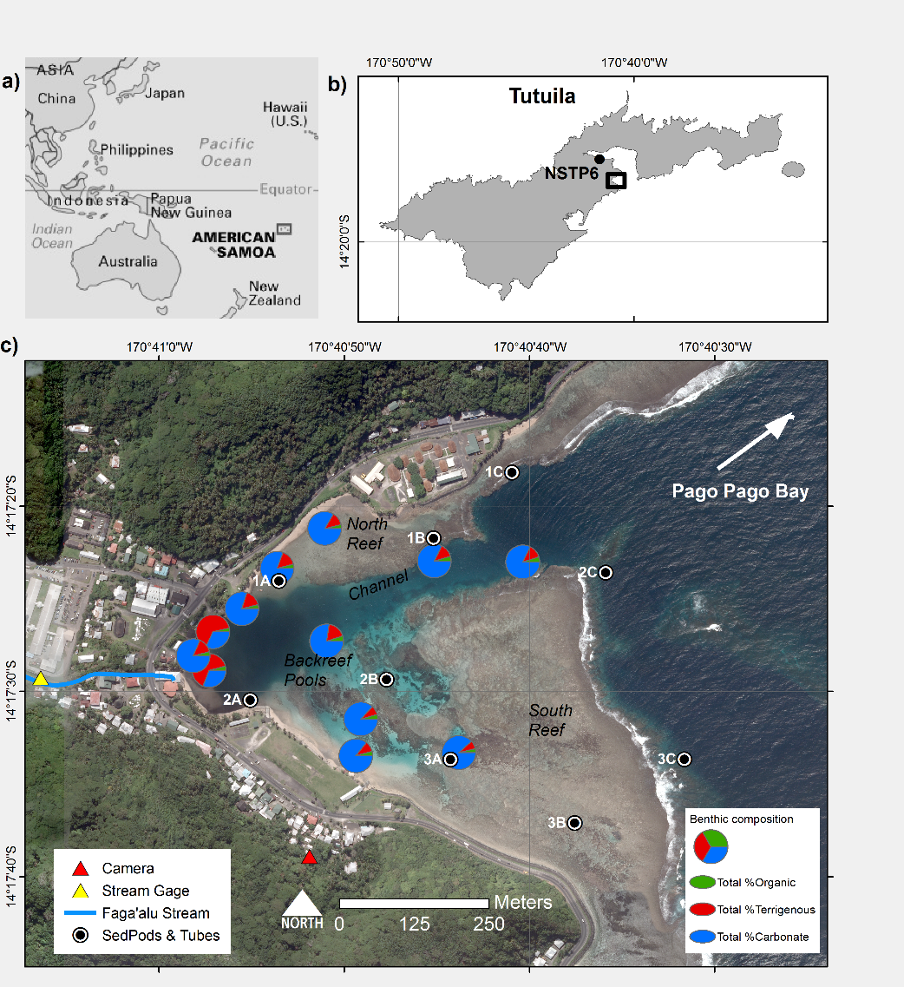

Figure . Study area

2.1 Study Area

2.1.1 Watershed: Suspended Sediment Yield

Faga'alu Bay is adjacent to a small (2.48 km2), steep-sided watershed that discharges terrigenous sediment during storm events from a perennial stream (Faga′alu Stream) in the northwest corner of the Bay, and several surrounding ephemeral streams (Messina and Biggs, 2016). Storms are most prevalent during the October-April wet season, but large storms can occur throughout the year.

The significant sediment contribution to Faga'alu Stream from an open-pit aggregate quarry in the watershed prompted installation of retention ponds and other mitigation efforts at the quarry to reduce sediment runoff. Sediment retention measures were installed in October 2014, and significantly reduced SSY (Messina and Biggs, In Preparation). See Holst-Rice et al. (2016) for a full description of sediment mitigation at the quarry.

Messina and Biggs (2016) developed an empirical model to predict event-wise suspended sediment yield (SSYEV) from maximum event water discharge (Qmax). A second Qmax-SSYEV model was calibrated for the time period following the sediment mitigation (October 2014-April 2015) to reflect the reduction in SSYEV from the same magnitude Qmax.

A time-series of SSYEV to the Bay during the study period was developed from measured SSYEV when both water discharge (Q) and suspended sediment concentration (SSC) data were available; when only Q data were available, predicted SSYEV from the empirical Qmax-SSYEV models were used (Figure 3b). Additional SSY to the Bay from areas not draining to Faga'alu Stream was not measured, and was assumed to be correlated with SSY from the main watershed.

2.1.2 Reef: Physical setting

Faga'alu Bay is a v-shaped, fringing-reef embayment situated on the western side of Pago Pago Bay, on the island of Tutuila, American Samoa (14.290˚ S, 170.677˚ W; Figure 1). The complex bathymetry is characterized by a shallow reef flat extending from shore to the reef crest, where it descends at an approximately 1:1 slope to the insular shelf at approximately 20 m depth. See Cochran et al. (2016) for a detailed description of the bathymetry. An anthropogenically-altered, vertical-walled, 5-15 m deep paleostream channel (“channel”) (Figure 1c) extends from the outlet of Faga'alu Stream in the northwest corner, eastward to Pago Pago Bay. This channel divides the reef into a larger, more exposed southern section (“southern reef” in Figure 1), and a smaller, more sheltered northern section (“northern reef” in Figure 1). Closer to the shore in the southern back-reef there are areas of deeper (1-5 m) sediment-floored pools with coral bommies (“back-reef pools” in Figure 1).

2.1.3 Reef: Benthic substrate characterization

Near the reef crest, the reef flat is primarily cemented reef pavement, but within a few 10s of m, transitions into thickets of primarily *Acropora spp.* Surveys in 2015 found coral coverage varied from less than 10% over the degraded northern area, to more than 50% on the more intact southern area (Cochran et al. 2016; Holst-Rice et al. 2016). Sediment availability is relatively low on the reef flats near the reef crest, though there are some patches of accumulated carbonate sediment. Near the stream outlet, the benthic surface is primarily sand and fine silt. Where possible, benthic surface sediment samples (top 2cm) were collected at several sites on the reef flat and channel (Figure 1c) by scooping sediment in 50 mL HDPE centrifuge tubes, which were then analyzed for chemical composition (see section 2.2.4 below).

2.1.4 Hydrodynamic forcing: waves, winds, water circulation

Faga'alu Bay is surrounded by high topography that blocks wet-season northerly winds from October to April, but is exposed to dry-season southeasterly trade winds and accompanying short-period waves. Trade winds are typically most prevalent and strongest from May to September, but are common throughout the year (Craig 2009). Tropical cyclones typically occur in the South Pacific from November to April (Militello et al. 2003), making landfall over American Samoa every 1-13 years since 1981 (Craig 2009), though cyclogenic waves impact the reefs more frequently (Feagaimaalii-Luamanu 2016). A semi-diurnal, microtidal regime exposes parts of the shallow reef crest and reef flat at extreme low tides, and water circulation increases with tidal height (Messina et al. *in press*). Faga'alu Bay is only open to south to southeast swell directions, and the more southerly angled swell must refract to the west, resulting in a reduction of wave energy. Offshore significant wave heights (*Hs*) are generally less than 2.5 m and rarely exceed 3.0 m. Peak wave periods (*Tp*) are generally about 9 s or less, rarely exceed 13 s, but occasionally reach 25 s during austral winter storms (Thompson and Demirbilek 2002). O. Vetter (unpublished data) recorded *Hs* up to 1.7 m on the fore reef in Faga'alu, but *Hs* greater than 1.0 m were infrequent.

GPS-logging drifter and acoustic current meter deployments in 2014 showed mean flow speeds (residence times) varied widely over the reef flat, from 1-20 cm s-1 (2.8-0.14 h), 1-19 cm s-1 (2.8-0.15 h), and 1-36 cm s-1 (2.8-0.08 h) under strong wind, tidal, and large wave forcing, respectively (Messina et al., In Press). The highest flow speeds and shortest residence times occurred over the exposed southern reef and near the reef crest. The slowest flow speeds and longest residence times occurred over the sheltered northern reef, near shore, and over the deep channel incised in the reef. Under tidal forcing (i.e., calm conditions), flow directions were the most variable, with some seaward transport from the southern reef flat to the fore reef. Under onshore wind forcing, flow directions were mostly into the embayment. Under large wave forcing, flows followed a clockwise spatial pattern: onshore over the exposed southern reef, onto the sheltered northern reef, and out to sea through the channel and over the forereef.

In situ wave data was not available at the study site during sediment trap deployments, but comparison of data from a wave gauge installed previously in Faga'alu for 2 months with NOAA WaveWatch III Samoa Regional Wave Model (WW3) (PACIOOS 2016) showed good agreement (Messina et al., *in press*). The Samoa Regional Model takes into account island bathymetry and island shadowing, so only swell directions from the Southwest to Southeast were included in the analysis, since other swell directions do not impact Faga'alu Bay. To characterize wave conditions during sediment trap deployments (“Waves”), Mean Monthly Significant Wave Height (MMSWH) was calculated from WW3 data on daily mean significant wave height during the period between collections (Seymour 2011; Rangel-Buitrago et al. 2014).

This analysis did not investigate the influence of winds directly, but wind waves generated by trade winds are included in the WW3 data. Strong trade winds are typical in May-September when significant wave height is also high due to trade wind generated waves and Austral winter storms. The co-occurrence of light winds and large groundswell-generated waves is infrequent but most common during the wet season from October to May. This analysis assumes the dominant effects of strong, onshore trade winds from the southeast are adequately captured by the WW3 significant wave height and would be significantly correlated with the Wave data.

2.2 Time-lapse photography of sediment plumes

A Moultrie GameSpy I-35 trail camera (“Camera” Figure 1) was installed on the south side of Faga'alu Bay in January and February 2014 to capture images of sediment plumes following storms. The camera was deployed in time-lapse mode at a 15 minute interval. While sediment concentrations cannot be inferred from the images, the brown-colored, terrigenous sediment was clearly visible, showing the spatial trajectory of the plume.

2.3 Sediment collection and composition



Figure . Pictures of the sediment tube traps and SedPods. a-b) At Site 3A in an area of branching coral rubble, approx.. depth 2m c) Capping the SedPod for retrieval at Site 1C, approx. 10m depth d) At Site 1B, the surrounding area is mixed terrigenous and carbonate benthic sediment.

2.3.1 Sampling scheme

Two types of sediment traps were used: flat-surfaced “SedPods” (Field et al. 2012a) and simple, tubular sediment traps (“Tubes”) (Storlazzi et al. 2009, 2011). Sediment traps were located to sample differences in sediment accumulation in two dimensions over the reef area: distance from the stream outlet, and hydrodynamic energy gradients across the south to north reefs. At each of nine locations in Faga'alu Bay a SedPod was attached on top of a cement block, and a Tube was attached to the side of the same block (Figure 2). Six sites were on the reef flat (water depth 1-2 m) and three sites were on the forereef (10-15 m) (Figure 1, Table 1).

A monthly time interval was chosen to correspond with other studies (Victor et al. 2006; Muzuka et al. 2010), to collect enough sediment for laboratory analysis, and for logistical reasons due to limited field personnel and resources. Collection dates varied due to safety concerns over dangerous diving conditions on the forereef; deployments varied from 24 d to 53 d, with a mean deployment of 36 days (Figure 3c, dotted lines), covering a 12 month period from March 2014 to April 2015.

2.3.2 Tubes

Tubes were made from 5 cm internal diameter PVC pipe, approximately 30 cm tall (), and capped at the bottom. Storlazzi et al. (2011) recommends a height-to-diameter ratio of at least 5, preferably more than 7; the ratio in this study was 6. To collect sediment from the Tube, a PVC cap was slipped over the open end, and then the Tube was removed from the block. In the lab, the cap was removed and the sediment was rinsed from the inside of the Tube. Some studies deploy multiple Tubes at each site to determine an average accumulation rate, and Bothner et al. (2006) found that sediment accumulation rates at co-located Tubes differed by 11% on average. This study deployed a single Tube to minimize hydrodynamic interference per Storlazzi et al. (2011).

2.3.3 SedPods

SedPods were made from 15.25 cm diameter PVC pipe, approximately 12 cm tall, and filled with cement with three eye-bolts to act as rebar and attachment points. The cement was poured on a rough piece of plywood to give it a slight texture approximating natural rock (Field et al. 2012a). To collect the sediment from SedPods, a rubber pipe end cap was carefully slipped over the SedPod taking care not to disturb the sediment, and the stainless steel hose clamp was tightened to prevent sediment from escaping during transport to the lab (Figure 3). In the lab, the rubber cap was removed and the sediment on the surface of the SedPod was rinsed off and analyzed for weight, grain size and composition. In many instances there was significant algal growth on the SedPod surface, so sediment was manually scrubbed from this algae layer and included in the analysis.

2.3.4 Weight, grain size, and composition analysis

Sediment was wet sieved to remove gravel-size shells and organisms (>2 mm) from analysis, and to separate the coarse (2 mm – 63 μm) and fine fractions (63 μm - 2 μm). The fine fraction was collected on pre-weighed 15-cm diameter, 2-μm nominal pore size glass fiber filters. To remove salts, the coarse fraction was rinsed in the sieve with distilled water, while the fine fraction was gravity rinsed with distilled water at least three times. Coarse and fine fractions were dried at 100 C for 2 hr, cooled, and weighed to determine the bulk sediment weight. The sediment samples were then analyzed for geochemical composition using Loss on Ignition (LOI) method (combusting 3 hr at 550 C for % organic; 950 C for 3 hr for % carbonate) (Heiri et al. 2001; Santisteban et al. 2004). The proportion (%) of terrigenous sediment was then determined by subtraction from the % organic and % carbonate (Gray et al. 2012). Wet sieving conducted by different lab analysts showed an unacceptable difference in coarse and fine fraction separation, so only combined fine and coarse fraction (total) sediment accumulation data were used in further analyses. Sediment accumulation results were normalized for trap diameter and deployment time (g m-2d-1) (Storlazzi et al. 2009) to compare SedPods and Tubes and variable deployment times

2.4 Sediment collection and composition: Temporal patterns and controls

For each of the nine sediment trap locations, univariate and multi-variate linear regression models were used to determine how SSY (tons) and Waves (m) control the temporal variation in sediment accumulation rates in Tubes and SedPods. The significance of the correlation between sediment accumulation and individual driving variables (SSY or Waves) were tested with the Spearman correlation coefficient. A linear regression between SSY and Waves confirmed they were not significantly related and could be treated as independent variables in the multiple regression. A multiple linear regression between sediment accumulation vs. SSY and Waves quantifies how well each predictor is correlated with sediment accumulation, while controlling for the influence of the secondary predictor. This approach does not account for the phasing or sequencing of Waves and SSY within deployment periods. For instance if a large wave event occurred prior to a large SSY event, we would not expect the wave event to affect sediment accumulation from that SSY, but our measurement interval cannot resolve the difference in phasing or sequence.

3. Results

3.1 Conceptual and observed SSY and Waves during deployment

Seasonal wave and precipitation patterns were hypothesized to vary such that large waves and low SSY coincide during the trade wind dry season (May-September), which would cause low terrigenous sediment accumulation. Hypothesized low wave energy and high SSY during the wet season (October-April) would cause higher terrigenous sediment accumulation (Figure 3a). Waves mostly followed the conceptual pattern with peak wave energy occurring around June-August and lowest wave energy during December-February, with the exception of larger than expected Waves in April 2014 and January 2015 (Figure 3c). While the conceptual model of Waves was similar to observed, measured and modeled SSY did not follow the conceptual model. The highest SSY was observed during the July-September 2014 period for two reasons: 1) the largest single storm recorded in the past four years occurred July 25, 2014, (Messina and Biggs 2016), and 2) sediment mitigation at the quarry in October significantly reduced total SSY from the watershed that would have occurred during the 2014-2015 wet season (October-April) (Holst-Rice et al. 2016).

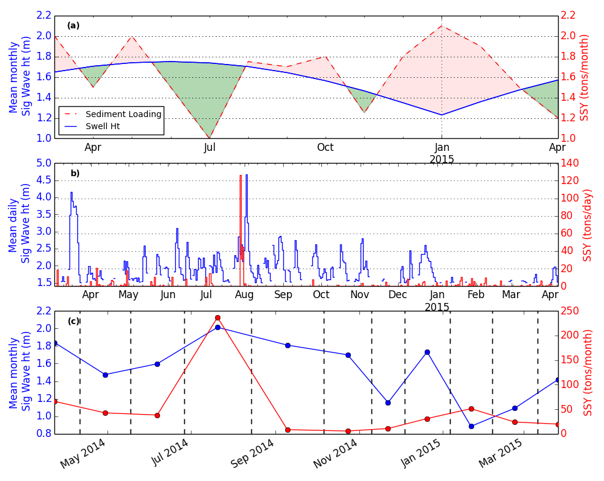

Figure . a) Conceptual model of net sediment accumulation driven by interacting sediment input and wave-forced sediment removal, b) Mean daily significant wave height (m) exceeding 1.5 m from the NOAA WaveWatch III Samoa Regional Model and Total daily Suspended Sediment Yield (SSY) (tons), and c) Mean Wave Height (m) and Total Suspended Sediment Yield during deployment periods (dashed lines indicate sample collection dates).

3.2 Time-lapse photography of sediment plumes

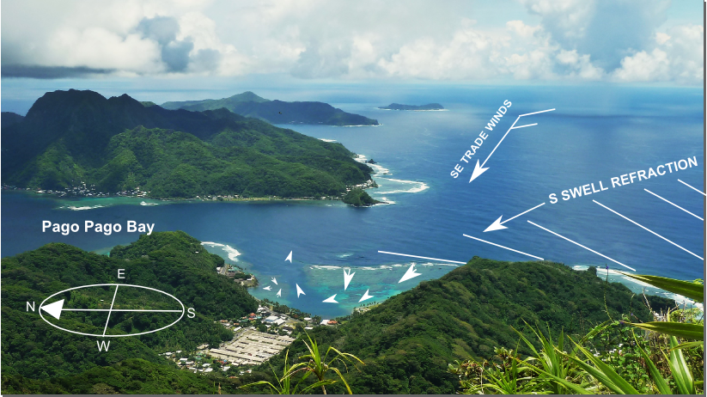

Camera

view

a)

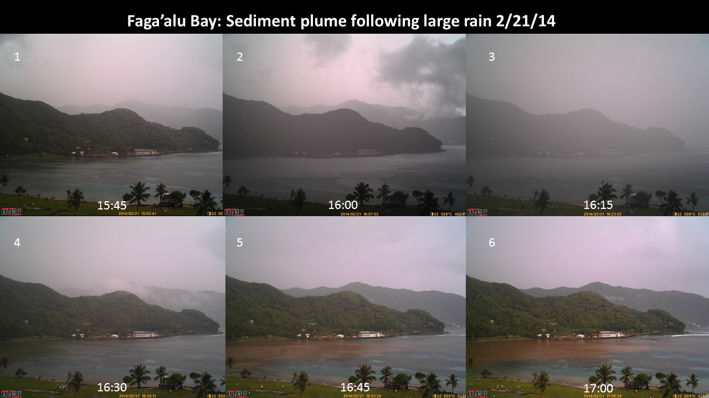

channel

Sediment plume over North reef and channel

North reef

South reef

Stream outlet

Figure .a) Illustration of dominant wind and wave-forcing, and resulting water flow patterns `````b) Time series of sediment plume following a brief but intense rainfall. In frame 1 the Bay is clear of any sediment plume but following a short burst of rainfall in frame 2 and 3, a sediment plume is discharged from the stream outlet (frames 4-6) where it is deflected away from the South reef, over the North reef and channel, and out to sea. Later frames showed the same spatial pattern, and an apparent diminishing of sediment concentrations over the northern reef.

Time-lapse camera deployment in Januar-February 2014, prior to the sediment trap deployment period, showed storms caused sediment discharge into the northwest corner of the Bay shortly after the beginning of rainfall (Figure 4). Field observations

showed that plume migration exceeded water flow velocity by moving over the water in a thin layer.

The spatial flow pattern suggests by deflecting the sediment plume away from the South Reef, over the North Reef, the impact of reduced photosynthesis is more acute over the North Reef. Field observations showed sediment plumes during storms extended from the stream to seaward of the reef crest and persisted for several hours to days. While particle settling on coral is important, recent work by Storlazzi et al. (2015) showed low concentration of fine grain sediment in the water column (10 mg/L) reduced photosynthetically active radiation by ~80% at depths of only 0.2-0.4 m.

Settling velocity strongly depends on particle size with large non-linear differences due to both grain size flocculation. Water properties including salinity and temperature are variable in a mixed freshwater/seawater plume and strongly influence settling velocity. We have no data for any of these parameters, especially not at the scale of our flow measurements.

Assuming these parameters could be constrained, settling velocity is also strongly influenced by sea state, flow conditions, and benthic topography that vary at much finer scale than our hydrodynamic measurements. Assuming these could be constrained and some likely range of settling velocities could be estimated, it would vary widely over the depths of the reef (0-15 m) so settling would have to be estimated in three dimensions. Given these complexities I think it is sufficient to say that sediment plumes during storms are observed to flow seaward of the reef crest on the North reef, thereby exposing the entire reef flat to sediment stress by light reduction. Stress by particle settling is much more complicated.

Stoke’s settling velocity of clay/silt in seawater is roughly 0-0.5 cm/s. For depths of 1 m settling time is ~33 min for particle size 63um, increasing to ~166 min for particle size 30um. Res. Times >=1 hr are observed on the North reef under WIND/TIDE so sediment settling could possibly occur

(Storlazzi et al. 2015) estimates settling time varies from 0.02 hr/m for coarse sands up to 1000 hr/m for clays, but more importantly sediment in water column attenuates light and shifts color spectrum to yellow/green light, reducing effective radiation for photosynthesis (Jones et al. 2015)

3.3 Sediment collection and composition: spatial patterns

3.3.1 Benthic sediment composition and texture

It might be assumed that the stream is the only source of fine terrigenous sediment, but spatial heterogeneity in carbonate/terrigenous fraction followed a common pattern observed in fringing reef embayments (Schrimm et al. 2004), where terrigenous sediment is distributed throughout the reef flat with the highest percentages near the stream outlet and reef channel. Fine terrigenous sediment accounted for 1-10% (μ=3%), though including the coarse fraction increased the total percentage to 8-65%, with the highest percentages of fine and terrigenous sediment near the stream outlet and on the northern reef. Total benthic sediment (fine and coarse) on the northern and southern reef flats was primarily carbonate (82-88%) with small fractions of terrigenous and only trace amounts of organics (Table1). The terrigenous fraction was approximately 1.5-2x higher over the northern reef flat (~15%) compared to the southern reef flat (8%). Near the stream outlet, benthic sediment was dominated by the terrigenous fraction (65% terrigenous) but showed similar percentages of organics as the reef flats.

3.3.2 Spatial patterns of sediment accumulation in traps

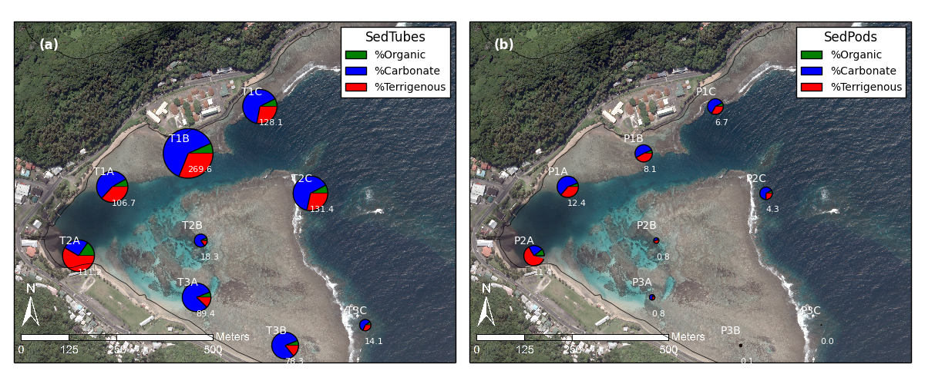

Figure . Mean accumulation rate (g m-2 d-1) and composition in a) Tubes and b) SedPods. Note: Subplot scales are different for visualization purposes, can’t compare sizes of charts, hence numbers included.

Total sediment accumulation (gm-2d-1) averaged over the study period was an order of magnitude higher in Tubes than on SedPods at all locations (Figure 5), indicating the enhanced trapping efficiency of Tubes and reduced resuspension compared to SedPods. Sediment accumulation on SedPods was much higher in the more quiescent parts of the Bay near the stream outlet (2A) and on the northern reef (1A-C), while almost no sediment accumulation was observed on SedPods over the southern reef (Figure 5b). Nearly the same spatial pattern and relative magnitude of sediment accumulation rates was observed in Tubes (Figure 5a) with the exception of 3A and 3B on the south reef. At these locations, frequent wave-forced flow appears to drive carbonate sediment over the reef flat, where it was trapped in Tubes but not on SedPods. Mean carbonate sediment accumulation rates at 3A and 3B were also strongly influenced by one period of high sediment accumulation related to a high wave event that occurred just before the collection date for the period of March 2014 (Figure 3b). Sediment accumulation at 2B (Tube) was lower than other sites on the southern reef flat (3A, 3B), likely due to low availability of surrounding benthic sediment, and a deeper deployment depth where resuspension is less frequent.

Though total sediment accumulation was higher in Tubes, the average percent contribution of organic, terrigenous, and carbonate sediments were similar between Tubes and SedPods for each location. With the exception of 2A, sediment accumulation on both the north and south reefs was dominated by the carbonate fraction, illustrating that resuspension of carbonate sediment dominates sediment transport.

On the southern reef, the ratio of terrigenous and carbonate sediment accumulation observed in traps mainly reflected the composition of surrounding benthic sediment, indicating the sediment source was resuspended, locally available benthic sediment. For the southern reef, 3A and 3B showed the largest relative increase in terrigenous fraction compared to surrounding benthic sediment, likely due to some small storm drains emptying into the Bay near those sites.

On the northern reef, sediment traps showed both the percent contribution and total amount of terrigenous sediment accumulation was higher near the stream outlet (2A), on the northern reef flat (1A, 1B) and forereef near the channel (1C, 2C), indicating both the influence of stream-supplied sediment during the deployment period and the resuspension of previously deposited terrigenous sediment in these areas. Benthic sediment on the north reef and especially near the stream outlet contains a higher percentage of terrigenous sediment (Figure 1), which can influence the composition of sediment accumulated in traps to the degree that accumulation is influenced by resuspension and deposition of surrounding benthic sediment. All Tubes, especially on the northern reef showed higher terrigenous fractions than the surrounding benthic sediment, indicating terrigenous sediment is advecting through the area but not accumulating on the bed, similar to results in (Storlazzi et al. 2009).

3.4 Sediment collection and composition: Temporal Patterns

3.4.1 Mean sediment accumulation on north and south reefs

#### 3.4.1.1 SedPods

Following the clear spatial differences in sediment accumulation (Figure 5), sites on the northern and southern reefs were grouped, and mean sediment accumulation was calculated to investigate temporal patterns. Sites 1A, 1B, 1C, 2A, and 2C were classified as the “northern reef” and sites 2B, 3A, 3B, and 3C as the “southern reef” (Table 1). On the southern reef, mean sediment accumulation on SedPods was much lower, and nearly zero compared to the northern reef for all periods (Figure 6). On the northern reef, mean sediment accumulation rates on SedPods loosely followed the hypothesized pattern of lower sediment accumulation during the May-October trade wind season, and higher sedimetation during the October-April wet season but the patterns were not very strong (Figure 6a).

Sediment accumulation on the SedPods was expected to be highest during low Waves due to lower removal rates, which is observed in Noveber 2014, when mean total sediment accumulation in the tubes was lowest, suggesting low resuspension rates.

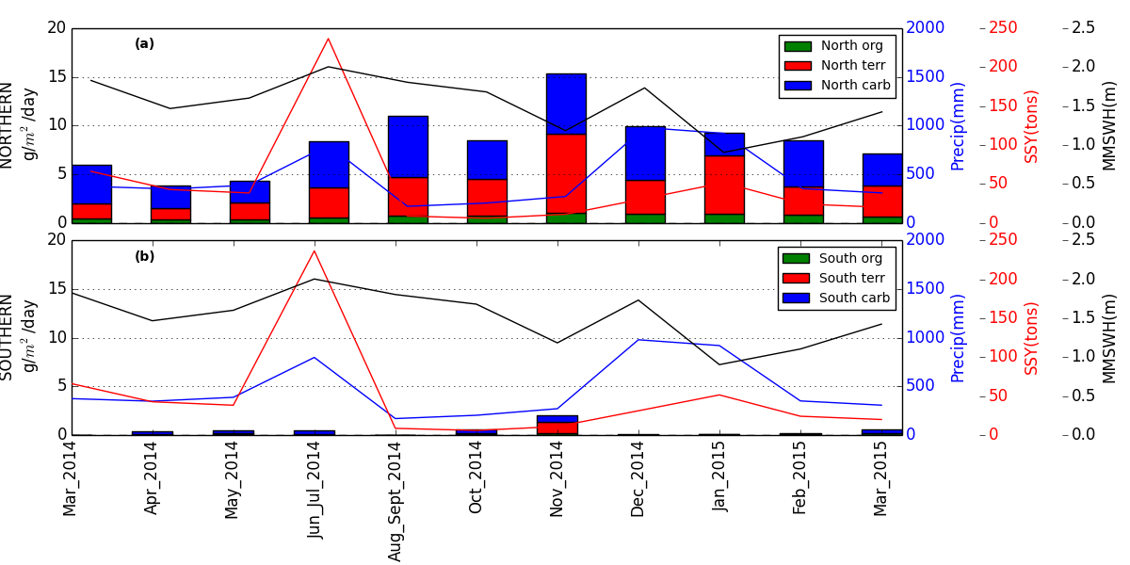

Figure . Mean sediment accumulation on SedPods during the study period over the a) north reef including sites 1A, 1B, 1C, 2A, 2C, and b) south reefs including sites 2B, 3A, 3B, 3C.

#### 3.4.1.2 Tubes

Similar to the results for SedPods, mean sediment accumulation rates in Tubes were higher on the northern reef than the southern reef for all deployment periods.

On both the northern and southern reefs the three periods with highest wave heights (March 2014, June-July 2014, and December 2014) were associated with the highest rates of carbonate sediment accumulation in Tubes. Conversely, mean terrigenous sediment accumulation in Tubes did not seem to follow any pattern in SSY, Waves, or precipitation, and seemed to occur at a fairly constant rate over the study period. This is not surprising given the variation in the range of hydrodynamic conditions, surrounding benthic sediment, and distance from the stream outlet that characterize individual sediment trap locations. While the mean sediment accumulation rates illustrate broad characterizations of sediment regimes over the northern and southern reefs, no strong temporal patterns in terrigenous sediment accumulation were evident.

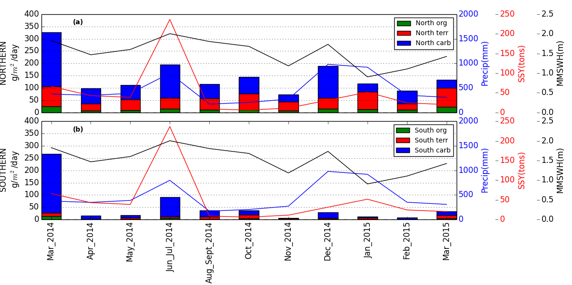

Figure . Mean sediment accumulation in Tubes during the study period over the a) north reef including sites 1A, 1B, 1C, 2A, 2C, and b) south reefs including sites 2B, 3A, 3B, 3C

3.4.2 Sediment accumulation at each location

#### 3.4.2.1 SedPods

Terrigenous sediment accumulation on SedPods did not correlate with SSY. Carbonate sediment accumulation on SedPods correlated weakly with Waves at one site (Figure 8) (Table 2). Spearman correlation coefficients between sediment accumulation (Total, Terrigenous, Terrigenous+Organic, and Carbonate) and SSY, and between sediment accumulation and Waves showed only a few significant correlations, and nearly all were negative correlations with Waves (Table 2). A negative correlation between sediment accumulation and Waves would indicate that sediment is being removed or that sediment deposition was prevented by active hydrodynamic conditions. The only positive correlation, between carbonate sediment and waves at P1A, indicated that wave-driven resuspension caused enhanced deposition of locally-derived sediment at that site.

Terrigenous sediment accumulation on SedPods was highest near the stream outlet (2A) and where conditions are calmest (1A, 1B) (Figure 8), but did not correlate with SSY or Waves (Table 2). Terrigenous sediment accumulation was also high on the forereef near the channel (1C, 10 m depth, and 2C, 15 m depth), suggesting terrigenous sediment may be advected through the channel to the forereef.

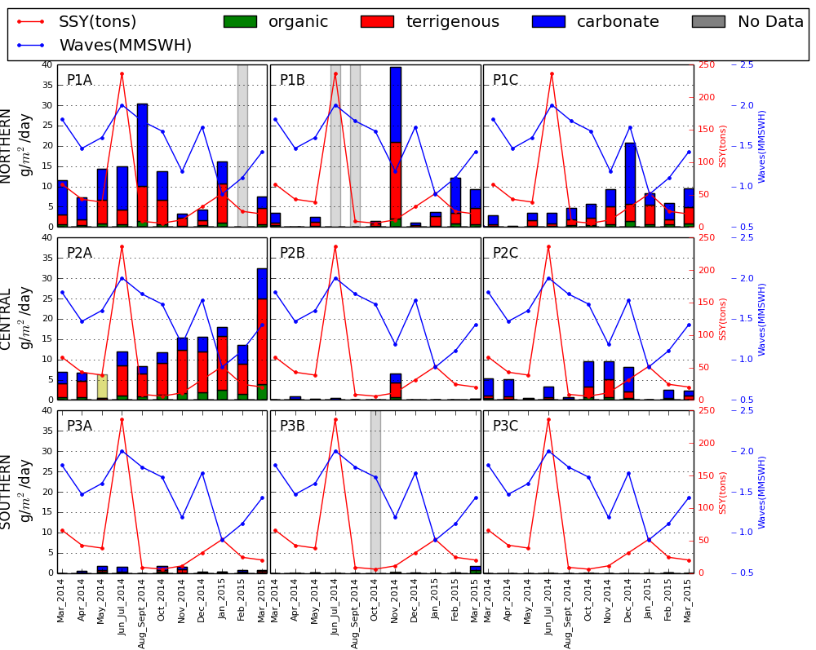

Figure . Time series' of sediment accumulation on SedPods and composition at nine sediment trap locations in Faga'alu Bay, related to suspended sediment yield from the watershed (SSY) and mean monthly significant wave height (MMSWH in m). “P” indicates SedPod and location ID’s (ex. 2A) correspond to sediment trap locations in Figure 1.

#### 3.4.2.2 Tubes

Sediment accumulation in Tubes reflected similar spatial patterns as the SedPods, with higher sediment accumulation at sites near the stream outlet and quiescent parts of the Bay (Figure 9), but the Tubes recorded significantly higher sediment accumulation overall, and especially in several energetic areas of the reef flat like at 3A, 3B, and 1B. In some periods, sediment accumulation rates on the northern reef exceeded literature values for coral health impact thresholds (Figure 9). On the southern reef, only the sites nearest shore exceeded health thresholds, and these were primarily due to high carbonate sediment accumulation.

Sediment accumulation rates, particularly of carbonates, in Tubes were positively correlated with Waves at every site except 2A, 2B, and 3C, and with mean sediment accumulation on the north and south reefs, indicating wave energy is a strong control on sediment dynamics on both the reef flat and forereef (Table 2).

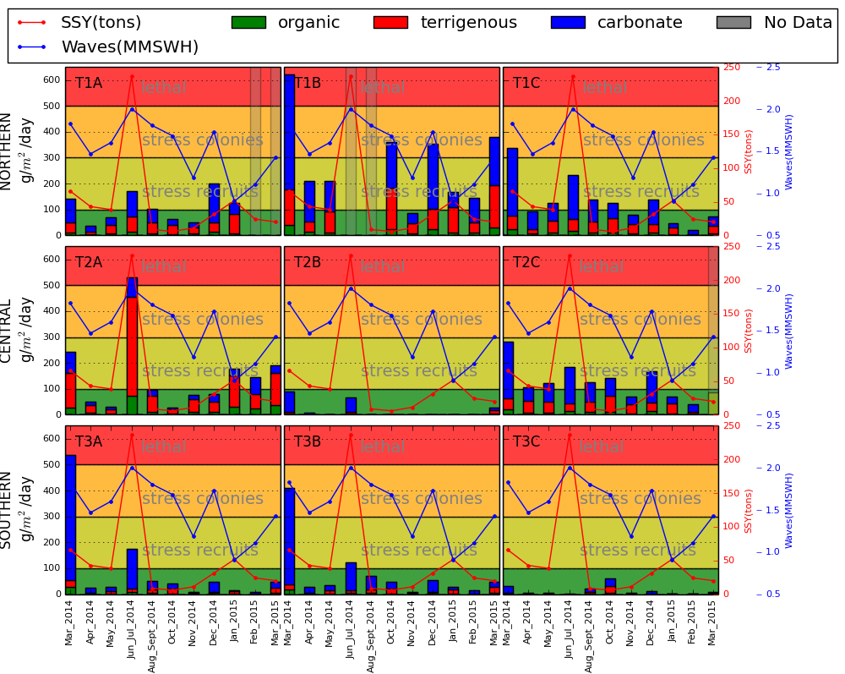

Figure . Time series' of sediment accumulation in simple tube traps and composition at nine sediment trap locations in Faga'alu Bay, related to suspended sediment yield from the watershed (SSY) and mean monthly significant wave height (MMSWH in m). “T” indicates Tube and location ID’s (ex. 2A) correspond to sediment trap locations in Figure 1. Coral health thresholds related to sediment accumulation in tubes from Erftemeijer et al. (2012) are included for reference only.

Total and carbonate sediment accumulation on the reef flat sites 1A, 1B, 3A, and 3B were also strongly correlated with Waves, according to Spearman coefficients (Table 2), but only 1B showed significant correlation when controlling for SSY (Table 3, p-value). Sediment accumulation rates at these sites are likely influenced by wave-driven resuspension of locally available carbonate sediment that was deposited in the Tube, but did not remain on the SedPod due to energetic hydrodynamic conditions.

Both total and carbonate sediment accumulation correlated with Waves at all forereef sites (1C, 2C, 3C) according to both Spearman correlation and multiple regression, indicating Waves are the dominant control on sediment mobilization on the forereef, but the results from SedPods suggest residence time of deposited sediment is very short in these energetic areas. Carbonate sediment accumulation showed a nonlinear relationship with Waves in many cases (Figure 10).

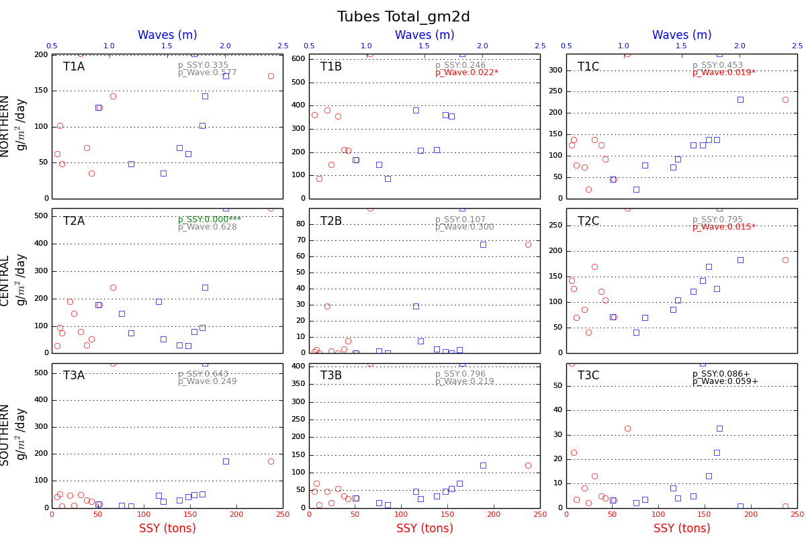

Figure . Correlations between total sediment accumulation in tubes vs SSY, Waves. P-values are for multiple regression

Only two sites (2A and 2B) were not correlated with Waves, which could be an indication of the lack of wave-driven resuspension in the case of 2A or a lack of benthic sediment availability in the case of 2B. Site 2A is in the most quiescent part of the bay and site 2B is in deeper water than the other reef flat sites (Table 1) on coral rubble with very little sediment near the Tube. This suggests the carbonate sediment being mobilized and transported across the shallow reef flat (like what is observed at 3A and 3B) is deposited as the flow enters the deeper, back reef pools and currents slow (shown by drifters in Messina et al. (*in press*)).

The strongest correlation between sediment accumulation (both Total and Terrigenous) and SSY was at 2A, near the stream mouth where hydrodynamics are less influenced by Waves. The Spearman correlation coefficient was non-significant for terrigenous (Table 2), but when controlling for Waves, the significant p-value for SSY in the multiple regression indicated SSY was a strong control on terrigenous sediment accumulation in the Tube at 2A (Table 3). This suggests that complex hydrodynamic forcing and resuspension of locally available sediment at the more exposed sites on the northern reef are strong controls on sediment accumulation, and not simply a result of SSY.

4. Discussion

4.1. Spatial distribution of sediment accumulation

Here’s where you can compare your sampling density with others, like you did in the abstract. What was learned from such high density sampling that hasn’t been learned by other methods?

Waves were a dominant control on sediment accumulation over time, but the spatial distribution of sediment accumulation was decoupled from wave height and flow velocity. Flow velocities are highest on the southern reef (xx m/s during wave-forcing conditions, Messina et al, in review), but sediment accumulation, both tubes and pods, was lowest there. In the northern reef, where deposition rates are highest, flow velocities are typically lower than on the southern reef (average xx m/s). The high sediment accumulation rates in the northern reef, especially higher rates of carbonate sediments, is hypothesized to be related to local sediment availability in the vicinity of the trap, and that sediment availability is higher on the northern reef. One of the pods with high sediment accumulation rates (1B) was surrounded by carbonate and terrigenous sediment (Figure 3). The two traps on the northern reef that were surrounded by sand (1A, 2A) had higher sediment accumulation rates (mean xx g/m2/d) compared with traps on the northern reef that were surrounded by coral (xx g/m2/d). The spatial distribution of sediment accumulation is likely governed by benthic sediment availability rather than the spatial distribution of flow velocity or wave height.

Most studies don’t situate their sites to explicitly measure gradients away from streams or differences in hydrodynamic energy or current directions. DeMartini sited traps going away from stream but only in one dimension, not sure what would be observed over the area. Bothner and Gray sited traps haphazardly offshore of stream outlets so you don’t know what the relative intensity of sediment impact is at that site, since sediment accumulation decays strongly with distance, shown by DeMartini; you have to measure from point of strongest impact to no impact to really understand relative importance.

Availability of carbonate sediment is higher on the northern reef due to lower coral cover there (and long-term accumulation of carbonate sediment due to lack of flushing of decomposed coral. Availability of terrigenous sediment is higher on the northern reef due to deflection of storm-derived sediment plumes to the north by the prevailing clockwise flow (Figure 1).

On the northern reef the terrigenous fraction in Tubes and SedPods was enriched compared to benthic sediment at all sites, indicating the influence of either stream-supplied sediment or resuspension and advection of benthic sediment with a high terrigenous percent near the stream mouth (e.g. 2A). Given the spatial configuration of the reef and the observed current patterns in Messina et al., (*in press*), resuspension is a possible source. However, the area near the stream outlet is relatively calm and water residence times are high, so resuspension and advection are assumed to be relatively low.

Table 4—why “RST” for rotating tube trap? Not RTT? Discuss what Table 4 tells you in more detail. Rotating Sediment Trap

4.2 Temporal distribution of sediment accumulation: Interaction of Sediment Yield and Waves

Sediment accumulation was significantly correlated with SSY from the watershed at only one location near the stream outlet, but the influence of SSY from the watershed on the northern reef was evident in the enriched terrigenous fraction of benthic sediment and sediment accumulation in Tubes and on SedPods. Other studies have shown strong correlations between storm-supplied terrigenous sediment and sediment accumulation in Tubes, but fine terrigenous sediment was rapidly removed (Storlazzi et al. 2009; Field et al. 2012b), making it difficult to capture with the monthly sampling interval used here.

Others, including Storlazzi et al. (2009), use sophisticated hydrographic instrumentation to document and found good relationships between fine, terrigenous sediment accumulation and bottom shear stress, but required sophisticated hydrodynamic instrumentation. We used a simple approach with low cost materials that would be feasible given limited resources of local managers.

Other studies have investigated temporal dynamics of flood-supplied sediment and waves qualitatively (Bothner et al. 2006; Draut et al. 2009; Gray et al. 2012; DeMartini et al. 2013) but few have quantitatively described temporal patterns with statistical analyses of sediment input or wave energy (Storlazzi et al. 2009). The statistical analysis used here was advantageous for providing more than qualitative or anecdotal description of sediment accumulation results, and instead provided a broad understanding of sediment controlling processes in the Bay.

Other studies conducted in more sheltered areas with less frequent SSY from storm events observed close relationships between terrigenous sediment accumulation and SSY but did not conduct statistical correlations (Bothner et al. 2006; Draut et al. 2009; Storlazzi et al. 2009; Gray et al. 2012). Our study site was exposed to complex and dynamic SSY and Waves, with several small to medium SSY events during most periods, several periods of high waves, and frequent small to medium waves. These complex dynamics varied at timescales shorter than our sediment accumulation measurements, complicating documentation of temporal controls. Despite the dynamic complexity of sediment yield, resuspension, and deposition, consistent patterns were observed between mean wave height and sediment accumulation of both total and carbonate sediments (Figure 10), particularly on the southern and outer parts of the reef. The temporal patterns of sediment accumulation suggest that resuspension of benthic sediment around the traps is a dominant source of sediment, but that terrigenous inputs and their orientation to prevailing hydrodynamic forcing are important for determining the composition of the benthic sediment. Terrigenous sediment plumes are deflected north by wave action over the reefs on the southern end of the bay, resulting in higher terrigenous sediment in both benthic and resuspended sediment.

Previous work in Faga'alu documented that human disturbance has increased SSY to the bay by ~3.6 times over the natural background, due in large part to an open pit quarry in the watershed. The enhanced terrigenous fraction in the northern part of the bay may reflect this enhanced terrestrial yield, and our data suggest that resuspension of that material after deposition is a continuing source of sediment accumulation in the coral environment. Critical questions remain about the residence time of the anthropogenic sediment and the timescale of recovery.

4.2 Interpreting comparisons of Tube vs SedPod results

On the southern reef, sediment accumulation in March 2014 was anomalously high due to high carbonate sediment accumulation in Tubes at 3A and 3B during that period. Wave-induced resuspension of nearby benthic sediment was the likely cause but similarly high Waves during other periods did not cause the same magnitude of sediment accumulation. The discrepancy could be due to the calculation of mean monthly wave height which would be the same for a period of low to medium wave events that caused little resuspension, versus a period of low Waves punctuated by one exceptionally high wave event that caused exponentially more resuspension, which appears to be the case in March 2014 (Figure 3b). There is also the possibility that carbonate sediment builds up over periods of low waves and trade winds during the wet season. The store of carbonate sediment could then be resuspended and advected through the reef during the onset of large swell events and depleted until the following wet season, but our data were too limited to further investigate that potential temporal pattern.

Tubes showed an order of magnitude higher sediment accumulation, particularly in areas of high flows like 3A, 3B, and 1B, but similar patterns in quiescent parts of the bay (2A, 1A). Other studies have shown that Tubes recorded transient suspended sediment while the surrounding benthic sediment suggested there was no net sediment accumulation (Bothner et al. 2006; Storlazzi et al. 2009). Tube sediment traps potentially overestimate sediment accumulation rates by slowing the water column to allow more deposition, and preventing resuspension of deposited sediment (Storlazzi et al. 2011), which means they provide better information on what sediment is moving through an area than what accumulates there. This is supported by the texture of sediment collected in our tubes. The sediment texture collected in the tubes was finer than that of the benthic sediment, suggesting that the tubes are retaining finer fractions than are being deposited on the reef, and that the sediment collected in them reflects sediment moving in an through the system rather than sediment that is depositing on the reef. As a consequence, measured sediment accumulation rates in tubes cannot be used to estimate long term accumulation rates or impacts on coral health, though both are often done (Teneva et al. 2016). Coral health may be affected by other factors than sediment accumulation rates, including blockage of solar radiation by turbidity, so information on how much sediment is in the water column, as represented by the measurements in the tubes, could be an important indicator of sediment-caused coral stress. Also, if the tubes are constructed with standardized dimensions or height to width ratios, they can be used to compare different sites or determine transient sediment regimes impacting benthic organisms.

Our results showed the advantage of deploying both Tubes and SedPods at the same location to show differences in gross and net sediment accumulation across hydrodynamic energy gradients. For example, while sediment accumulation on the SedPod at 1B was the lowest of the northern reef sites, sediment accumulation in the Tube at 1B was the highest of the northern reef sites. This indicates resuspended sediment was likely deposited in the Tube where it was not removed, while resuspended sediment deposited on the SedPod was frequently removed by relatively more energetic wave conditions at 1B compared to other northern reef sites. At 1B, total and terrigenous sediment accumulation on the SedPod was negatively correlated with waves, while total and carbonate sediment accumulation in the Tube was positively correlated with waves. The multiple regression also supported these correlations.

4.3 Comparison with other Sites

Many studies just put their traps out near rivermouths Bothner, Storlazzi, Gray and do not explicitly sample a spatial gradient. Wolanski 2005 sampled over a depth gradient but only for a week

Finer temporal resolution usually means shorter study and less variability of conditions. Wolanski et al. (2005) used daily rates but only deployed for 5 days at 6 sites, and then used a one week deployment during a storm.

Similar to other studies on a shallow reef flat exposed to wind waves and long-period ocean swell on Molokai, Hawaii, we observed that frequent resuspension, likely driven by trade wind waves, was the dominant contribution to total transport (Presto et al. 2006), and most sediment in Tubes was reef-derived. Our results showed similar magnitudes of sediment accumulation rates other studies in similar fringing reef settings (Table 4), but comparisons must take into account wave exposure and terrigenous sediment supply from the adjacent watershed.

The sediment accumulation rates we observed in tubes were (higher/lower/similar) to those measured by others, including in the Virgin Islands (Gray, data range), others….

How does Fagaalu compare with other sites? Unusually high? Low? Other?

Sediment accumulation of terrigenous material may be tightly coupled to watershed loading either near the river mouth (as in Faga'alu) or in sheltered bays with limited resuspension (like Grays?—what was Gray’s terrigenous fraction?). Further from the stream mouth, or in bays with more energetic circulation, sediment accumulation rates on a monthly timestep become decoupled from the time series of terrigenous sediment loading from the watershed, and instead are determined by resuspension by waves.

4.4 Relating sediment accumulation to coral health

The composition, grain size, organic content, and residence time of deposited sediment can cause widely different impacts even for the same coral species, and coral health impacts from similar sediment accumulation conditions can vary widely by species and coral life stage (colonies vs recruits). Ecologically relevant thresholds for harmful sediment accumulation rates on corals are not straightforward, are unavailable for SedPods, and can vary widely in the literature for simple tube traps (Erftemeijer et al. 2012). They are included in Figure 9 as a general reference, and not to imply specific impacts on coral health in Faga'alu Bay. On the northern reef these thresholds are exceeded during some deployment periods, and in some cases reaching lethal sediment accumulation rates. Coral health surveys reflect the same spatial pattern as sediment accumulation on SedPods, with lower coral health coincidental with higher sediment accumulation, particularly terrigenous sediment accumulation (Holst-Rice et al. 2016).

It is unknown what the effect of sediment mitigation in the watershed and observed decrease in SSY will be on coral health, particularly the time scale that recovery can be expected. Wave-driven resuspension of terrigenous sediment occurs frequently on the shallow reef flat, suggesting the built up store of terrigenous sediment will be advected from the reef flat, but it may be deposited on the northern fore reef where its residence time could be much longer (Wolanski et al. 2005). Given the apparent lag between deposition at the stream outlet, and subsequent resuspension and advection out over the northern reef, SSY may not be important to sediment accumulation at the event scale (or monthly) but would be important over longer time scales. These results also indicate that while higher sediment accumulation rates may not coincide with high loading from the watershed on a monthly time scale, frequent sediment plumes over the northern reef and resuspension may cause a persistent reduction of PAR and reduced coral health (Storlazzi et al. 2015).

4.5 Further work

With a quasi-monthly sampling interval it is not possible to assess daily sediment accumulation rates and to investigate the effects of phasing and sequence between daily SSY and daily wave conditions, which are likely very important to resulting sediment accumulation rates. A more sophisticated instrumentation approach to measuring accumulation like Thomas and Ridd (2005) or to measuring resuspension and transport like Pomeroy et al. (2015) would be necessary to develop higher resolution assessments of sediment accumulation, but the goal of this study was to investigate broad spatial and temporal trensds in a remote area to support management. Monitoring total light attenuation from suspended and deposited sediment particles would help quantify the impact of sediment on the coral environment.

4.6 Main takeaways

Tubes show sediment accumulation is higher on the northern reef due to water circulation patterns that deflect sediment plumes from the stream during storms. SedPods show energetic ocean conditions are moving mostly carbonate sediment over the southern reef by resuspension. Comparing Pods and Tubes showed where some areas might see high sediment accumulation in Tubes, but the actual residence time is low as shown by the SedPods. While other studies showed correlations between SSY and terrigenous sediment accumulation using monthly measurements (Draut et al. 2009), in the more dynamic Faga'alu reef, a shorter sampling interval is needed to better resolve the interaction of SSY and hydrodynamic conditions.

By deploying sediment traps across the whole Bay along gradients in depth, wave energy, water circulation and stream-supplied sediment, it was possible to see heterogeneous spatial patterns over short distances. This suggests sediment accumulation studies that rely on one or a few sediment traps near the stream outlet may be significantly overestimating sediment accumulation or the impact of flood-supplied sediment on the surrounding reef.

This study period included mitigation actions that significantly reduced SSY to the Bay, making precipitation a poor predictor of SSY and hence, sediment accumulation. In other watersheds where mitigation is planned, or land use change is ongoing it is strongly advised that in situ measurements of SSY from the stream are used. The approach presented in this paper illustrates how measurements of SSY from the stream, water circulation over the reef, and sediment accumulation in Tubes and SedPods can be used to support coral conservation. This approach was designed to be low cost and require few personnel and technical resources, yet still provide a full description of terrigenous sediment dynamics in the study site to recommend management efforts and determine their efficacy.

5. Acknowledgements

This work was carried out in collaboration between San Diego State University and the US Geological Survey's Pacific Coral Reef Project. Funding and support was provided by the NOAA Coral Reef Conservation Program (Award NA13NOS4820025) and the US Geological Survey's Coastal and Marine Geology Program. We would like to thank Dr. Michael Favazza and Alice Lawrence (DMWR) for providing logistical support in the field, and Meagan Curtis (DMWR), Jameson Newtson (ASCC), Ian Moffitt (NPS), Peter Talivaa (DMWR), Brian George, Esq. (Supreme Court of American Samoa), Jeremy Raynal (DMWR), Kristine Bucchianeri (DMWR), Hideyo Hattori (NOAA), and Dr. Tim Clark (NPS) for assisting in diving operations. Use of trademark names does not imply USGS endorsement of products.

6. References

Bartley R, Bainbridge ZT, Lewis SE, Kroon FJ, Wilkinson SN, Brodie JE, Silburn DM (2014) Relating sediment impacts on coral reefs to watershed sources, processes and management: a review. Sci. Total Environ. 468-469:1138–53

Basher L, Hicks D, Clapp B, Hewitt T (2011) Sediment yield response to large storm events and forest harvesting, Motueka River, New Zealand. New Zeal. J. Mar. Freshw. Res. 45:333–356

Bégin C, Brooks G, Larson R a., Dragićević S, Ramos Scharrón CE, Coté IM (2014) Increased sediment loads over coral reefs in Saint Lucia in relation to land use change in contributing watersheds. Ocean Coast. Manag. 95:35–45

Bellwood DR, Fulton CJ (2008) Sediment-mediated suppression of herbivory on coral reefs: Decreasing resilience to rising sea-levels and climate change? Limnol. Oceanogr. 53:2695–2701

Bever AJ, McNinch JE, Harris CK (2011) Hydrodynamics and sediment-transport in the nearshore of Poverty Bay, New Zealand: Observations of nearshore sediment segregation and oceanic storms. Cont. Shelf Res. 31:507–526

Bothner MH, Reynolds RL, Casso MA, Storlazzi CD, Field ME (2006) Quantity, composition, and source of sediment collected in sediment traps along the fringing coral reef off Molokai, Hawaii. Mar. Pollut. Bull. 52:1034–47

Brooks G, Devine B, Larson R, Rood B (2007) Sedimentary Development of Coral Bay , St . John , USVI : A Shift From Natural to Anthropogenic Influences. Caribb. J. Sci. 43:226–243

Browne NK., Smithers SG., Perry CT., Ridd PV. (2012) A Field-Based technique for measuring sediment flux on coral reefs: Application to turbid reefs on the great barrier reef. J. Coast. Res. 28:1247–1262

Clausing R, Annunziata C, Baker G, Lee C, Bittick S, Fong P (2014) Effects of sediment depth on algal turf height are mediated by interactions with fish herbivory on a fringing reef. Mar. Ecol. Prog. Ser. 517:121–129

Cochran SA, Gibbs AE, D’Antonio NL, Storlazzi CD (2016) Benthic habitat map of U.S. Coral Reef Task Force Faga‘alu Bay priority study area, Tutuila, American Samoa: U.S. Geological Survey Open-File Rport 2016-XXXX, XX.

Craig P (2009) Natural History Guide to American Samoa. National Park of American Samoa, Pago Pago, American Samoa

DeMartini E, Jokiel P, Beets J, Stender Y, Storlazzi C, Minton D, Conklin E (2013) Terrigenous sediment impact on coral recruitment and growth affects the use of coral habitat by recruit parrotfishes (F. Scaridae). J. Coast. Conserv. 17:417–429

Downs C a, Ostrander GK, Rougee L, Rongo T, Knutson S, Williams DE, Mendiola W, Holbrook J, Richmond RH (2012) The use of cellular diagnostics for identifying sub-lethal stress in reef corals. Ecotoxicology 21:768–82

Draut AE, Bothner MH, Field ME, Reynolds RL, Cochran, S.A.Logan JB, Storlazzi CD, Berg CJ (2009) Supply and dispersal of flood sediment from a steep, tropical watershed: Hanalei Bay, Kaua’i, Hawai'i, USA. Geol. Soc. Am. Bull. 121:574–585

Duvert C, Nord G, Gratiot N, Navratil O, Nadal-Romero E, Mathys N, Némery J, Regüés D, García-Ruiz JM, Gallart F, Esteves M (2012) Towards prediction of suspended sediment yield from peak discharge in small erodible mountainous catchments (0.45–22km2) of France, Mexico and Spain. J. Hydrol. 454-455:42–55

Erftemeijer PL a, Riegl B, Hoeksema BW, Todd P a. (2012) Environmental impacts of dredging and other sediment disturbances on corals: A review. Mar. Pollut. Bull. 64:1737–1765

Fabricius KE (2005) Effects of terrestrial runoff on the ecology of corals and coral reefs: review and synthesis. Mar. Pollut. Bull. 50:125–46

Fabricius KE, De’ath G, Humphrey C, Zagorskis I, Schaffelke B (2012) Intra-annual variation in turbidity in response to terrestrial runoff on near-shore coral reefs of the Great Barrier Reef. Estuar. Coast. Shelf Sci. 1–9

Fallon SJ, White J c., McCulloch MT (2002) Porites corals as recorders of mining and environmental impacts: Misima Island, Papua New Guinea. Geochim. Cosmochim. Acta 66:45–62

Feagaimaalii-Luamanu J (2016) High surf generated by TC Victor washes over roads and property. Samoa News

Field ME, Chezar H, Storlazzi CD (2012a) SedPods: a low-cost coral proxy for measuring net sedimentation. Coral Reefs

Field ME, Chezar H, Storlazzi CD (2012b) SedPods: a low-cost coral proxy for measuring net sedimentation. Coral Reefs 1–5

Goatley CHR, Bellwood DR (2012) Sediment suppresses herbivory across a coral reef depth gradient. Biol. Lett. 8:1016–8

Gray SC, Sears W, Kolupski ML, Hastings ZC, Przyuski NW, Fox MD, Degrood A (2012) Factors affecting land-based sedimentation in coastal bays, US Virgin Islands. 9–13

Heiri O, Lotter AF, Lemcke G (2001) Loss on ignition as a method for estimating organic and carbonate content in sediments : reproducibility and comparability of results. J. Paleolimnol. 25:101–110

Hettler J, Irion G, Lehmann B (1997) Environmental impact of mining waste disposal on a tropical lowland river system: a case study on the Ok Tedi Mine, Papua New Guinea. Miner. Depos. 32:280–291

Hoitink AJF, Hoekstra P (2003) Hydrodynamic control of the supply of reworked terrigenous sediment to coral reefs in the Bay of Banten (NW Java, Indonesia). Estuar. Coast. Shelf Sci. 58:743–755

Holst-Rice S, Messina A, Biggs TW, Vargas-Angel B, Whitall D (2016) Baseline Assessment of Fagaʻalu Watershed: A Ridge to Reef Assessment in Support of Sediment Reduction Activities and Future Evaluation of their Success.

Hopley D (2011) S. Encyclopedia of Modern Coral Reefs.

Jokiel PL, Rodgers KS, Storlazzi CD, Field ME, Lager C V., Lager D (2014) Response of reef corals on a fringing reef flat to elevated suspended-sediment concentrations: Molokaʻi, Hawaiʻi. PeerJ 2:

Jones R, Bessell-Browne P, Fisher R, Klonowski W, Slivkoff M (2015) Assessing the impacts of sediments from dredging on corals. Mar. Pollut. Bull.

Klein CJ, Jupiter SD, Selig ER, Watts ME, Halpern BS, Kamal M, Roelfsema C, Possingham HP (2012) Forest conservation delivers highly variable coral reef conservation outcomes. Ecol. Appl. 22:1246–56

Meng P-J, Lee H-J, Wang J-T, Chen C-C, Lin H-J, Tew KS, Hsieh W-J (2008) A long-term survey on anthropogenic impacts to the water quality of coral reefs, southern Taiwan. Environ. Pollut. 156:67–75

Messina AT, Biggs TW Comparing pre- and post-mitigation suspended sediment yields during storms in Faga’alu, American Samoa.

Messina AT, Biggs TW (2016) Contributions of human activities to suspended sediment yield during storm events from a small, steep, tropical watershed. J. Hydrol. XX:XX

Messina AT, Storlazzi CD, Biggs TW, Washburn L Eulerian and Lagrangian measurements of flow and residence time on a fringing reef flat embayment, American Samoa.

Militello A, Scheffner NW, Thompson EF (2003) Hurrican-Induced Stage-Frequency Relationships for the Territory of American Samoa. USACOE Technical Report CHL-98-33.

Muzuka ANN, Dubi AM, Muhando CA, Shaghude YW (2010) Impact of hydrographic parameters and seasonal variation in sediment fluxes on coral status at Chumbe and Bawe reefs, Zanzibar, Tanzania. Estuar. Coast. Shelf Sci. 89:137–144

PACIOOS PIOOS (2016) WaveWatch III Samoa Regional Model. http://oos.soest.hawaii.edu/pacioos/

Perry C, Smithers SG, Gulliver P, Browne NK (2012) Evidence of very rapid reef accretion and reef growth under high turbidity and terrigenous sedimentation. Geology 40:719–722

Pomeroy AWM, Lowe RJ, Ghisalberti M, Storlazzi CD, Cuttler M, Symonds G (2015) Mechanics of Sediment Suspension and Transport Within a Fringing Reef. 1–14

Presto MK, Ogston AS, Storlazzi CD, Field ME (2006) Temporal and spatial variability in the flow and dispersal of suspended-sediment on a fringing reef flat, Molokai, Hawaii. Estuar. Coast. Shelf Sci. 67:67–81

Ramos-Scharrón CE, Macdonald LH (2007) Measurement and prediction of natural and anthropogenic sediment sources, St. John, US Virgin Islands. Catena 71:250–266

Rangel-Buitrago N, Anfuso G, Phillips M, Thomas T, Alvarez O, Forero M (2014) Characterization of wave climate and extreme events into the SW Spanish and Wales coasts as a first step to define their wave energy potential. J. Coast. Res. 70:314–319

Rotmann S, Thomas S (2012) Coral tissue thickness as a bioindicator of mine-related turbidity stress on coral reefs at Lihir Island, Papua New Guinea. Oceanography 25:52–63

Ryan KE, Walsh JP, Corbett DR, Winter a (2008) A record of recent change in terrestrial sedimentation in a coral-reef environment, La Parguera, Puerto Rico: a response to coastal development? Mar. Pollut. Bull. 56:1177–83

Santisteban JI, Mediavilla R, Lopez-Pamo E, Dabrio CJ, Zapata MBR, Garcia MJG, Castano S, Martínez-Alfaro PE (2004) Loss on ignition: a qualitative or quantitative method for organic matter and carbonate mineral content in sediments? J. Paleolimnol. 32:287–299

Schrimm M, Buscail R, Adjeroud M (2004) Spatial variability of the biogeochemical composition of surface sediments in an insular coral reef ecosystem: Moorea, French Polynesia. Estuar. Coast. Shelf Sci. 60:515–528

Seymour RJ (2011) Evidence for Changes to the Northeast Pacific Wave Climate. J. Coast. Res. 27:194–201

Storlazzi CD, Field ME, Bothner MH (2011) The use (and misuse) of sediment traps in coral reef environments: theory, observations, and suggested protocols. Coral Reefs 30:23–38

Storlazzi CD, Field ME, Bothner MH, Presto MK, Draut AE (2009) Sedimentation processes in a coral reef embayment: Hanalei Bay, Kauai. Mar. Geol. 264:140–151

Storlazzi CD, Norris BK, Rosenberger KJ (2015) The influence of grain size, grain color, and suspended-sediment concentration on light attenuation: Why fine-grained terrestrial sediment is bad for coral reef ecosystems. Coral Reefs 34:967–975

Teneva LT, Mcmanus MA, Jerolmon C, Neuheimer AB, Clark SJ, Walker G, Kaho K, Shimabukuro E, Ostrander C, Kittinger JN (2016) Understanding Reef Flat Sediment Regimes and Hydrodynamics can Inform Erosion Mitigation on Land. Collabra 2:1–12

Thomas S, Ridd P (2005) Field assessment of innovative sensor for monitoring of sediment accumulation at inshore coral reefs. Mar. Pollut. Bull. 51:470–80

Thomas S, Ridd P V (2004) Review of methods to measure short time scale sediment accumulation. Mar. Geol. 207:95–114

Thompson EF, Demirbilek Z (2002) Wave Response, Pago Pago Harbor, Island of Tutuila, Territory of American Samoa. USACOE Coastal and Hydraulics Laboratory ERDC/CHL TR-02-20.

Vetter O (2013) Inter-Disciplinary Study of Flow Dynamics and Sedimentation Effects on Coral Colonies in Faga’alu Bay, American Samoa: Oceanographic Investigation Summary. NOAA CRCP Project #417.

Victor S, Neth L, Golbuu Y, Wolanski E, Richmond RH (2006) Sedimentation in mangroves and coral reefs in a wet tropical island, Pohnpei, Micronesia. Estuar. Coast. Shelf Sci. 66:409–416

Warrick JA, Mertes LAK, Washburn L, Siegel DA (2004) Dispersal forcing of southern California river plumes, based on field and remote sensing observations. Geo-Marine Lett. 24:46–52

Weber M, de Beer D, Lott C, Polerecky L, Kohls K, Abed RMM, Ferdelman TG, Fabricius KE (2012) Mechanisms of damage to corals exposed to sedimentation. Proc. Natl. Acad. Sci. 109:E1558–E1567

West K, van Woesik R (2001) Spatial and temporal variance of river discharge on Okinawa (Japan): inferring the temporal impact on adjacent coral reefs. Mar. Pollut. Bull. 42:864–72

Wolanski E, Fabricius KE, Spagnol S, Brinkman R (2005) Fine sediment budget on an inner-shelf coral-fringed island, Great Barrier Reef of Australia. Estuar. Coast. Shelf Sci. 65:153–158

Wolanski E, Richmond RH, Davis G, Bonito V (2003) Water and fine sediment dynamics in transient river plumes in a small, reef-fringed bay, Guam. Estuar. Coast. Shelf Sci. 56:1029–1040

Tables

Table 1. Sediment trap deployment locations and characteristics.

Table 2. Spearman correlation coefficients (p<0.1) for Sediment accumulation vs. SSY (ssy:), and Sediment accumulation vs. Waves (w:).

Table 3. Significant P-values for multiple regression of Sediment accumulation ~ SSY + Waves. ***=p<0.001, **=p<0.01, *=p<0.05, +=p<0.1.

Table 4. Comparison of sediment accumulation rates between Tubes and SedPod deployments in similar fringing reefs embayments.

Figure Captions

Figure 1. Maps of the study area and instrumentation in Faga'alu Bay. SedPods and simple tube traps (Tubes) were deployed at nine locations for one year and collected quasi-monthly to measure sediment accumulation rates and composition. Suspended sediment yield from the watershed was measured at “Stream Gage.” Further details on SSY measurements and modeling can be found in (Messina and Biggs, *in press*). A time-lapse camera was installed at “Camera” to record images of transient sediment plumes during storms.

Figure 2. Pictures of the sediment tube traps and SedPods at high tide. a-b) At Site 3A in an area of branching coral rubble, approximately 2m depth c) Capping the SedPod for retrieval at Site 1C, approx. 10m depth d) At Site 1B, the surrounding area is mixed terrigenous and carbonate benthic sediment.

Figure 3. a) Hypothetical phasing of monthly sediment loading from the watershed and offshore wave height *(Draut et al. 2009)*. Red shaded areas indicate a time of net terrigenous sediment accumulation and green shaded areas indicate a time of net terrigenous sediment removal and resuspension of marine-derived sediment, b) Mean daily significant wave height (m)exceeding 1.5 m from the NOAA WaveWatch III Samoa Regional Model and Total daily Suspended Sediment Yield (SSY) (tons), and c) Mean Wave Height (m) and Total Suspended Sediment Yield during deployment periods (dashed lines indicate sample collection dates).

Figure 4. a) Illustration of dominant wind and wave-forcing, and resulting water flow patterns b) Time series of sediment plume following a brief but intense rainfall. In frame 1 the Bay is clear of any sediment plume but following a short burst of rainfall in frames 2 and 3, a large sediment plume is discharged from the stream outlet (frames 4-6) where it is deflected away from the South reef, over the North reef and channel, and out to sea. Later frames showed the same spatial pattern, and an apparent diminishing of sediment concentrations over the northern reef.

Figure 5. Mean accumulation rate (gm2d) and composition in a) Tubes and b) SedPods. Note: Subplot scales are different for visualization purposes, can’t compare sizes of charts, hence numbers included.

Figure 6. Mean sediment accumulation on SedPods during the study period over the a) north reef including sites 1A, 1B, 1C, 2A, 2C, and b) south reefs including sites 2B, 3A, 3B, 3C.

Figure 6. Mean sediment accumulation in Tubes.

Figure 7. Mean sediment accumulation in Tubes during the study period over the a) north reef including sites 1A, 1B, 1C, 2A, 2C, and b) south reefs including sites 2B, 3A, 3B, 3C

Figure 8. Time series' of sediment accumulation on SedPods and composition at nine sediment trap locations in Faga'alu Bay, related to suspended sediment yield from the watershed (SSY) and mean monthly significant wave height (MMSWH in m). “P” indicates SedPod and location ID’s (ex. 2A) correspond to sediment trap locations in Figure 1.

Figure 9. Time series of sediment accumulation in simple tube traps and composition at nine sediment trap locations in Faga'alu Bay, related to suspended sediment yield from the watershed (SSY) and mean monthly significant wave height (MMSWH in m). “T” indicates Tube and location ID’s (ex. 2A) correspond to sediment trap locations in Figure 1. Coral health thresholds related to sediment accumulation in tubes from Erftemeijer et al. (2012) are included for reference only.

Figure 10. Correlations between total sediment accumulation vs SSY, Waves.